Title:

**Testing Gellner: Industrialization and the National Movement in the 19th Century Germany**

The 18th and 19th century in Europe were characterized by fundamental change and transformation. Industrialization, Modernization and Nationalism were the driving forces which prevailed all over Europe. Social scientists and historians have been fascinated with the question of how and why most European countries experienced such a strong rise of nationalism, which ended up in the building of a nation state. One of the most prominent scholars was Ernest Gellner.

**Gellner’s theory:**

Industrialization was the main factor for the transformation of agrarian societies into modern industrial societies. In an agrarian society a small group of aristocrats and scholars imposed their social system and culture on the rest of the society. The industrial revolution brought substantial social, economic and political developments. The feudal system came to an end, new classes emerged. Broad general education enabled people to choose their occupation and thus fostered social mobility. Technological innovations cultivated economic growth, made people mobile and enabled communication.

→ market integration, division of labor, technological innovation, economic growth, education, [bureaucratization](https://www.dict.cc/?s=bureaucratisation), social change

New personal autonomy demanded individuals to develop a new identity 🡪 the formation of a national identity.

Gellner opposes theories of a natural explanation for nationalism or that nationalism developed by coincidence. He draws a causal link between Industrialization and the spread of Nationalism. Nationalism is a social consequence of the transformation from an agrarian society into an industrial society. Moreover, he says the rise of nationalism was neither a top-down nor a bottom-up phenomena, it developed all over society.

**My Thesis**

The temporal accordance of Industrialization and nationalism suggests a link between these two phenomena.

Has not been empirically analyzed.

(Not clear yet) Questions I want to investigate: Is there a causal link between Industrialization and the spread of Nationalism? What role did the process of market integration and the social changes of the Industrialization play for the demand of a new national identity? Did other transformations brought by the Industrialization foster the rise of nationalism?

**Method/Data:**

Turnvereine are the proxy for Nationalism. Turnvereine were the biggest and best organized national movement in 19th century Germany. Members of the Turnvereine were socially heterogenous coming from different social classes.

The statistical yearbook of the Turnvereine from 1865 contains data on all existing Vereine in Germany with information on:

City; No. of Members; Date of founding; occupation

Sadly, only a cross sectional and not a longitudinal study of the Trunvereine is possible.

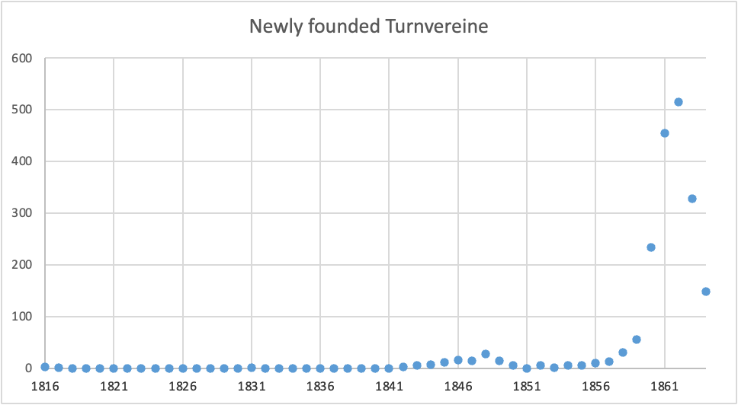 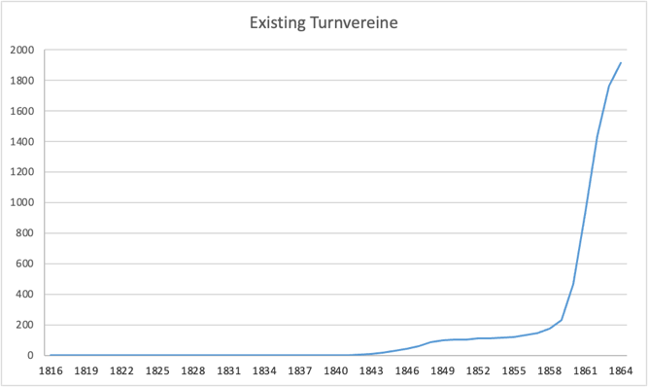

Till ´48 Turnvereine were still forbidden and till the 50s politically suppressed.

🡪Argument: Industrialization just kicked in around the 50s so a good point of time to investigate.

I will mostly focus on the Turnverein in Prussia and the Kingdom of Saxony; there they were the strongest and more important I only have Data of the Industrialization for these regions.

**Proxy for Industrialization not clear yet.**

For Saxony: Occupation Census of the Year 1861

Time fits perfect; many different variables for occupation make a precise analysis possible; sadly I only have the Data for bigger cities

For Prussia:

Different Occupation census for the years 1849, 1864, 1882

* Sadly only the 1882 census has information of the total working population (18 years later than the data of the Turnvereine) same census as in Weber Paper
* The 1864 only contains the number of people who worked in industry; no specification of job and I have no information of the rest of the working population and thus cannot say if this city is particularly industrialized or not
* 1849 census with data on farmers, factory workers, craftsmen, servants

Data on how many Factories, industrial machines and transportation systems in cities for the year 1848

Data on Education; 1864 number of Teachers and Students; 1871 literacy rates; Education is one of the most important arguments for Gellner and recent paper showed that Education is significantly associated with Industrialization.

🡪 So, question is which Data can I use to see if the Turnvereine spread or existed more in industrialized cities.

Were People living in Industrialized cities; or working in Industry jobs; or living in more educated cities more likely to be in a Turnverein?